The Standard Company

Standard Insurance Company
- Headquartered in Portland, Oregon
- Chartered in 1906 as Oregon Life Insurance Company
- Mutualized in 1929
- Name changed to Standard Insurance Company in 1946
- Demutualized in 1999
- Licensed in 49 states, the District of Columbia and the United States Territories of Guam, Puerto Rico and the Virgin Islands
- Number of employees in the Portland, Oregon home office: 1,768
- Number of employees in field and regional offices: 369
- Offices:
- 40 — Employee Benefits Sales and Service offices
- 9 — Individual Disability Insurance Regional offices
- Primary products:
  - Group disability insurance
  - Individual disability insurance
  - Group life insurance
  - Group accidental death and dismemberment insurance
  - Group dental insurance
  - Group vision insurance
  - Retirement plans
  - Annuities
- Absence Management Services
- Number of Employee Benefits policies in force: approximately 23,000
- Number of employees covered: approximately 6 million
- Number of individual insurance policies in force and individual annuities: approximately 176,000

The Standard Life Insurance Company of New York
- Headquartered in White Plains, New York
- Licensed in 2000
- Number of employees: 79
- Products:
- Group disability insurance
- Individual disability insurance
- Group life insurance
- Group accidental death and dismemberment insurance
- Group dental insurance
- Group vision insurance

StanCorp Investment Advisers, Inc.
- Headquartered in Portland, Oregon
- Licensed in 2000
- Number of employees: 16

Standard Retirement Services, Inc.
- Headquartered in Portland, Oregon
- Organized in January 2007
- Number of employees: 388
- 30 offices nationwide including sales offices
- Administration and servicing operations for retirement plans group annuity contracts
- Trust products

StanCorp Mortgage Investors, LLC
- Headquartered in Hillsboro, Oregon
- Organized in 1996
- Number of employees: 79
- Offices: 1 — Tanasbourne home office in Hillsboro, Oregon
- Origination, participation and servicing of commercial mortgage loans
- Amount of mortgage loans under administration for StanCorp Financial Group, Inc.: $5.54 billion
- Amount of mortgage loans under administration for other investors: $3.43 billion
- Total number of loans under management: approximately 6,400

Position
A Software Engineer, for the Core Engineering team

Position Key Points
- Willing to go distance
- UML
- REST
- Keen ability to present and promote your assessments, ideas and conceptual views. Very much at ease with person-to-person interactions - high respect for all ideas.
- Curious mind, desire for continuous learning and to master new technologies.
- Demonstrable experience in:
  - HTML, XML, SQL/SOQL, and REST/SOAP-based web services
  - Javascript frameworks (i.e. Angular)
  - Java web services (e.g. Spring or other frameworks)
  - Continuous integration/delivery
  - Software/system architecture and software/system design using UML

Key Points
Ability to present and promote assessments, ideas and views
Development of Masters Thesis
Teaching
- Biology
- Rad Physics
Restructuring of how staff handled data
- Mess got team on board
Restructuring of Server
- Had to get buy in of everyone so they understood new changes
  - Responsible for new code being 15% the size of old structure and 27% of original file size
Legacy Internship
- Director and presentation outcome

Curious mind, desire for continuous learning and to master new technologies.
Always reading and learning trying to stay on top
Current Learning
- Responsive Design
- Better CSS Style and formatting (surprisingly complicated)

SORT
IT Coordinator
- Data Report
  - Fit this role due to business and software together
  - financial 80 pages
  - Simplified to 5 pages
  - Java and Python

Personal Projects
Software Development for masters

Reasons I Like This Role
Ability to work side by side with business

“As a member of our IT team, you work side by side with the business, pursuing strategic opportunities for our company. It’s an exciting time with new products, new distribution channels and new customer needs that are driving big investments in technology. At The Standard, we are large enough for big opportunities and small enough for big impact.”

Questions
Tell me about a time when you used data and logic to present information in order to persuade an individual on a difficult subject?

Tell me about a time you have used humor to diffuse or ease an uncomfortable or difficult situation.

My Questions
Day to day and environment
More details about position
Training
Hiring Timeline
In what ways does company use technology
How is software and technology positioned in company

Technical

Java

JVM
JVM is an acronym for Java Virtual Machine, it is an abstract machine which provides the runtime environment in which java bytecode can be executed. It is a specification.
JVMs are available for many hardware and software platforms (so JVM is platform dependent).

JRE
JRE stands for Java Runtime Environment. It is the implementation of JVM.

JDK
JDK is an acronym for Java Development Kit. It physically exists. It contains JRE + development tools.

What is platform?
A platform is basically the hardware or software environment in which a program runs. There are two types of platforms software-based and hardware-based. Java provides software-based platform.

What gives Java its 'write once and run anywhere' nature?
The bytecode. Java is compiled to be a byte code which is the intermediate language between source code and machine code. This byte code is not platform specific and hence can be fed to any platform.

What is difference between object oriented programming language and object based programming language?

Object based programming languages follow all the features of OOPs except Inheritance. Examples of object based programming languages are JavaScript, VBScript etc.

What is constructor?
Constructor is just like a method that is used to initialize the state of an object. It is invoked at the time of object creation.
Returns current instance

What is static method?
A static method belongs to the class rather than object of a class.
A static method can be invoked without the need for creating an instance of a class static method can access static data member and can change the value of it.

Static Variable
When a variable is declared with the keyword “static”, its called a “class variable”. All instances share the same copy of the variable. A class variable can be accessed directly with the class, without the need to create a instance.

What is this in java?
It is a keyword that that refers to the current object

What is method overloading?
If a class have multiple methods by same name but different parameters, it is known as Method Overloading. It increases the readability of the program

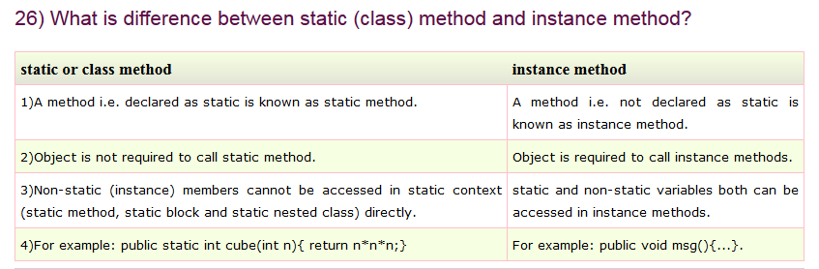

What is Inheritance?

Inheritance is a mechanism in which one object acquires all the properties and behaviour of another object of another class. It represents IS-A relationship. It is used for Code Resusability and Method Overriding.

Why Java does not support pointers?

Pointer is a variable that refers to the memory address. They are not used in java because they are unsafe(unsecured) and complex to understand.

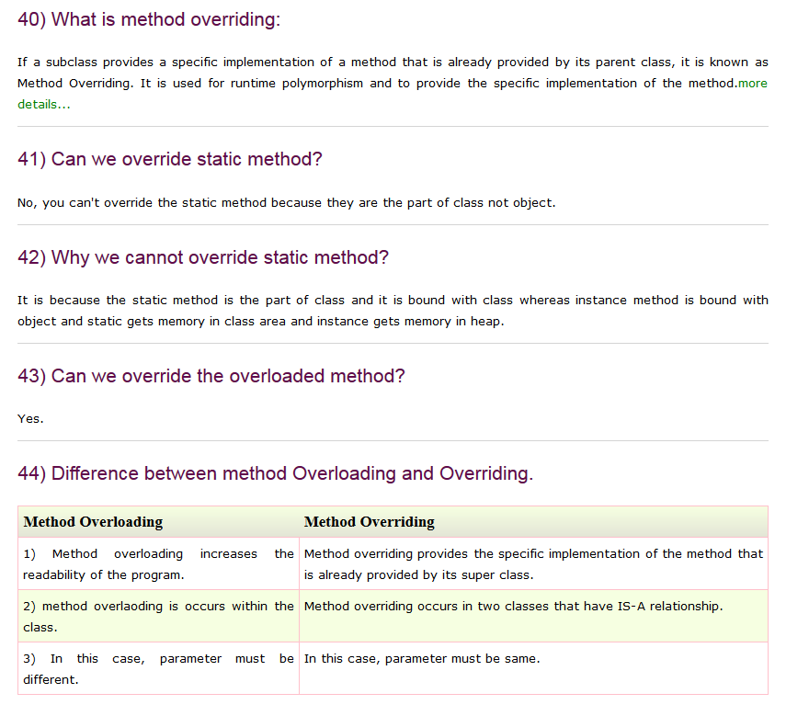

47) What is final variable?

If you make any variable as final, you cannot change the value of final variable(It will be constant).more details...

48) What is final method?

Final methods can't be overriden.more details...

49) What is final class?

Final class can't be inherited. more details...

50) What is blank final variable?

A final variable, not initalized at the time of declaration, is known as blank final variable.more details...
51) Can we intialize blank final variable?

Yes, only in constructor if it is non-static. If it is static blank final variable, it can be initialized only in the static block.more details...

52) Can you declare the main method as final?
Yes, such as, public static final void main(String[] args){}.

Rest
REST stands for Representational State Transfer. (It is sometimes spelled "ReST".) It relies on a stateless, client-server, cacheable communications protocol and in virtually all cases, the HTTP protocol is used.

UML
UML diagrams
Structural UML diagrams
- Class diagram
- Component diagram
- Composite structure diagram
- Deployment diagram
- Object diagram
- Package diagram
- Profile diagram

Behavioral UML diagrams
- Activity diagram
- Communication diagram
- Interaction overview diagram
- Sequence diagram
- State diagram
- Timing diagram
- Use case diagram

SQL
Inner Join
The INNER JOIN keyword selects all rows from both tables as long as there is a match between the columns in both tables.
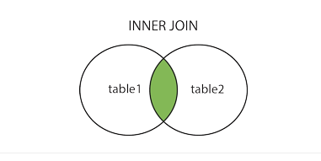

Left Join
The LEFT JOIN keyword returns all rows from the left table (table1), with the matching rows in the right table. The result is NULL in the right side when there is no match.

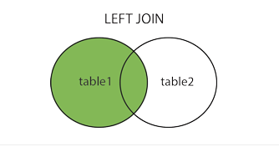

Right Join
The RIGHT JOIN keyword returns all rows from the right table, with the matching rows in the left table (table1). The result is NULL in the left side when there is no match.
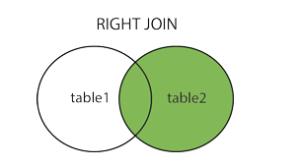

Full Outer Join
SQL FULL OUTER JOIN Keyword
The FULL OUTER JOIN keyword returns all rows from the left table (table1) and from the right table.

The SQL UNION Operator
The UNION operator is used to combine the result-set of two or more SELECT statements.

Notice that each SELECT statement within the UNION must have the same number of columns. The columns must also have similar data types. Also, the columns in each SELECT statement must be in the same order.

What are Build Tools

What are build tools?
Build tools are programs that automate the creation of executable applications from source code(eg. .apk for android app). Building incorporates compiling,linking and packaging the code into a usable or executable form.

Basically build automation is the act of scripting or automating a wide variety of tasks that software developers do in their day-to-day activities like:
- Downloading dependencies.
- Compiling source code into binary code.
- Packaging that binary code.
- Running tests.
- Deployment to production systems.

Why do we use build tools or build automation?
In small projects, developers will often manually invoke the build process. This is not practical for larger projects, where it is very hard to keep track of what needs to be built, in what sequence and what dependencies there are in the building process. Using an automation tool allows the build process to be more consistent.

Various build tools available(Naming only few):
- For java - Ant,Maven,Gradle.
- For .NET framework - NAnt
- c# - MsBuild.

Java Spring
The Spring Framework is a Java platform that provides comprehensive infrastructure support for developing Java applications. Spring handles the infrastructure so you can focus on your application.
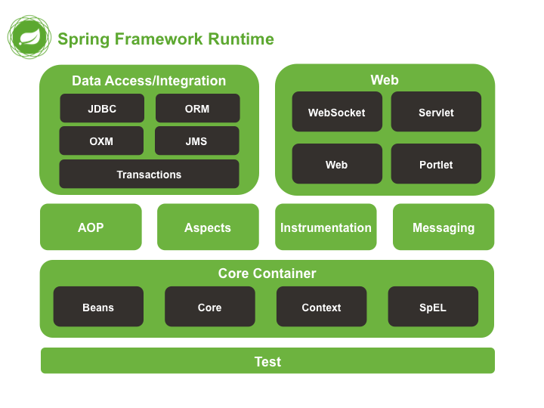

Basically Spring is a framework for dependency-injection which is a pattern that allows to build very decoupled systems. I'll try to explain you the simplest I can (this isn't a short answer).
The problem

For example, suppose you need to list the users of the system and thus declare an interface called UserLister:

public interface UserLister {
List<User> getUsers();
}

And maybe an implementation accessing a database to get all the users:

public class UserListerDB implements UserLister {
public List<User> getUsers() {
// DB access code here
}
}

In your view you'll need to access an instance (just an example, remember):

public class SomeView {
private UserLister userLister;

public void render() {
List<User> users = userLister.getUsers();
view.render(users);
}
}

Note that the code above doesn't have initialized the variable userLister. What should we do? If I explicitly instantiate the object like this:

UserLister userLister = new UserListerDB();

...I'd couple the view with my implementation of the class that access the DB. What if I want to switch from the DB implementation to another that gets the user list from a comma-separated file (remember, it's an example)? In that case I would go to my code again and change the last line by:

UserLister userLister = new UserListerCommaSeparatedFile();

This has no problem with a small program like this but... What happens in a program that has hundreds of views and a similar number of business classes. The maintenance becomes a nightmare!
Spring (Dependency Injection) approach

What Spring does is to wire the classes up by using a XML file, this way all the objects are instantiated and initialized by Spring and injected in the right places (Servlets, Web Frameworks, Business classes, DAOs, etc, etc, etc...).

Going back to the example in Spring we just need to have a setter for the userLister field and have an XML like this:

This will actually work
// without adding any line of code

It is great! Isn't it?

What if you want to use another implementation of your UserLister interface? Just change the XML
What if don't have a UserLister implementation ready? Program a temporal mock implementation of UserLister and ease the development of the view
What if I don't want to use Spring anymore? Just don't use it! Your application isn't coupled to it. Inversion of Control states: "The application controls the framework, not the framework controls the application".

There are some other options for Dependency Injection around there, what in my opinion has made Spring so famous besides its simplicity, elegance and stability is that the guys of SpringSource have programmed many many POJOs that help to integrate Spring with many other common frameworks without being intrusive in your application. Also Spring has several good subprojects like Spring MVC, Spring WebFlow, Spring Security and again a loooong list of etceteras.

Hope this helps. Anyway, I encourage you to read Martin Fowler's article about Dependency Injection and Inversion of Control because he does it better than me. After understanding the basics take a look to Spring Documentation, in my opinion is used to be the best Spring book ever.

